MOTHER Protocol for Comparing Two QuPath Annotations

Gaurika Shah, Masara Azooz, Alessia Daniele, Kirstin Austin, Yian Ding,

James P. Sluka, Karen H. Watanabe

I. Overview 2

A. Before You Start 2

II. Getting Started with Jupyter Notebook 2

III. Running the Jupyter Notebook 3

IV. Generated Output Files 5

V. Annotations Consensus 8

VI. Troubleshooting 9

VII. References 14

VIII. Acknowledgments 14

# Overview

This document is a protocol that describes the procedures for comparing ovary follicle annotations in digitized histology images between two trained annotators. The follicle annotations should be done with QuPath software Bankhead, et al. (2017) following the MOTHER project follicle annotation protocols Sluka, et al. (2023,Sluka, et al. (2023), and to minimize errors we create a consensus count. This protocol includes a step-by-step procedure for creating a consensus count from two independent annotators, running a Jupyter Notebook Python script that does the comparison, recording notes in a workflow log, and troubleshooting. QuPath is an open-source software that allows users to delineate and analyze specific areas of interest. The Jupyter Notebook enables users to execute Python code in a step-by-step manner for creating and sharing computational documents. These tools are versatile in that they encourage iterative approaches to image analysis by allowing users to reproduce analyses and results. This protocol is a reference for how to use the “Comparing Two Annotators” Jupyter Notebook for ovarian follicle annotation comparisons. With minor modifications, the Jupyter Notebook could be adapted for other types of histology images and morphological patterns including microvessel and/or nuclear density.

## Before You Start

Before using the Jupyter Notebook’s Python script to create a consensus count and its results folder, make sure both annotators have used the same version of QuPath to annotate an ovary histology image. Version 0.4.3 has been used extensively by the MOTHER annotators devoid of any major issues or bugs. Version(s) 0.4.4 and 0.5.0 are currently being tested for their performance. This can be downloaded from QuPath’s release(s) catalog at: <https://github.com/qupath/qupath/releases/>

# Getting Started with Jupyter Notebook

1. Make a copy of the notebook ("**ComparingTwoAnnotators.ipynb**").
   1. The master copy can be downloaded from the folder at:   
      <https://github.com/mother-db/MOTHER-DB-annotation-tools/tree/main/CompareTwoAnnotators>, select the file named “ComparingTwoAnnotators.ipynb”
   2. Paste it in the folder that contains the exported QuPath annotation files being compared (Eg: *Rapamycin_rhesus_OvaryHistology*).
   3. Rename the copy as: ‘**ComparingTwoAnnotators_ASURITE.ipynb*’***, where ASURITE is the ASURITE of the person running the Jupyter Notebook(Eg: ComparingTwoAnnotators_gshah5.ipynb).
2. Ensure you have a local copy and full path to the following files:
   1. The two annotators’ QuPath measurement (.**txt**)files (E.g.,*‘AnimalID_XX_Slidenumber_ASURITE_annotations.txt’*)
   2. The original image for the section being compared (i.e. the **ome.tif** file)
      1. Having the full path to the original image is needed, but a copy does not need to be in the consensus count folder.
      2. If utilizing file hosting services (i.e., Dropbox, Google Drive, etc.), ensure that the image files are downloaded in a specific directory on your device by doing the following:
         1. If using Dropbox on a PC or Windows device-
            1. Double-click on the image file and ensure it loads fully on an image viewer
            2. Note a green check mark next to the image icon as an indicator
            3. If not, open the Dropbox App from the desktop bar, click on your name icon in the top right corner, select preferences $→$ sync $→$ select folders. Checkmark all of the files in the consensus folder as well as the ome.tif image file.
         2. If using Dropbox on a **Mac** device-
            1. Right-click on the image name; this will open a dropdown menu.
            2. Select “Make available offline”.
   3. Create a consensus count folder to store the output from the Jupyter Notebook. For the MOTHER project,
      1. The location of the consensus folder should be in the **animal ID folder** of the section being compared.
      2. Name it as: ***AnimalID_XX_Slidenumber_follicleCounting_Annotator1_Annotator2_consensus.*** For the MOTHER project replace “Annotator1” and “Annotator2” with each annotator’s ASURITE ID.
      3. Example*: 30381_LT_050c_follicleCounting_mazooz_gshah5_consensus*

# Running the Jupyter Notebook

1. Ensure you are using the 6.4.8 version by navigating to “Anaconda Navigator (Anaconda3)” from the Windows search bar (PC users) or launchpad (Mac users).
   1. By default, all application tiles are displayed on the home screen. From the home page, click on the “launch” tab corresponding to “Jupyter Notebook.” This should direct you to a new files tab, select your own Jupyter Notebook copy found in the MOTHER Dropbox folder.

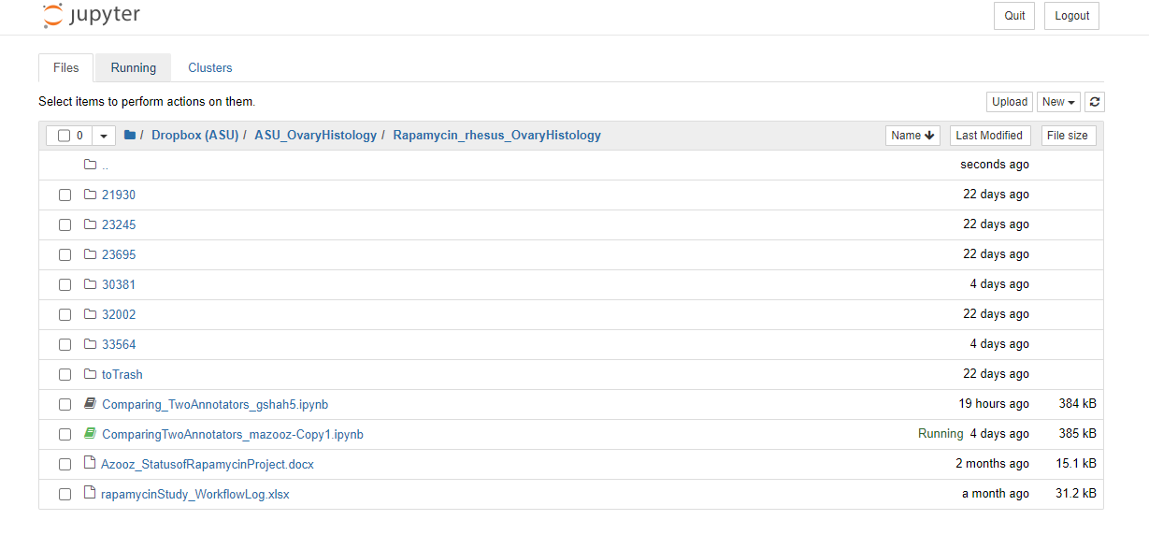

1. Follow the instructions under the “enter needed info” section of the notebook to add the paths to the required files. Be careful with all the punctuation and spaces. Refer to the given examples in the notebook.
2. Under ‘fname1’ and ‘fname2’, edit the information to include the full paths to “Annotator 1” and “Annotator 2” measurement files respectively. See below:

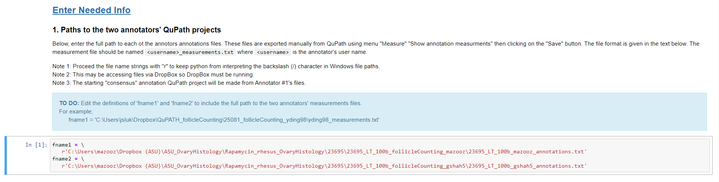

1. Edit the text of the ‘imagePath’ to include the full path to the original, full-resolution image (i.e, **ome.tif file**). See below: 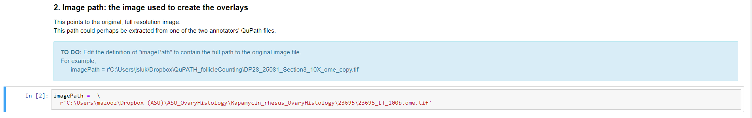
2. Edit the text of ‘path’ to include the full path to the output directory folder (i.e. the consensus counts folder). 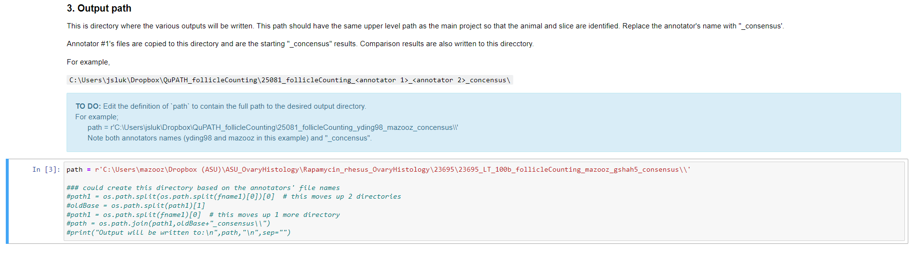
3. Start running the code once you have added all the required information.
   1. To run the code, select “Cell” from the toolbar on the top left-hand side and click on the “Run All” option.
   2. The notebook should autosave your work. If the autosave function is not working, manually save the project. To do so, click on the save icon located to the far left. 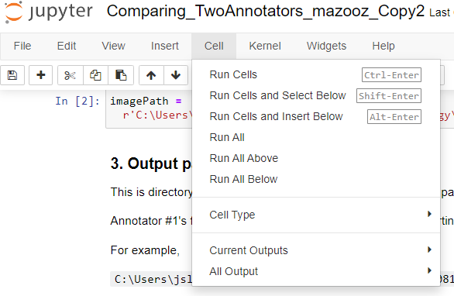

**→**

# Generated Output Files

The following section outlines the list of files (23 in total) stored in the consensus folder after a successful jupyter notebook run. The entire folder set of user 1’s QuPath project is copied into the consensus folder as it serves as the basis for finding the agreements and disagreements between both projects’ annotations. See **Table 1** for a summary of the output file names and descriptions. An incomplete list suggests errors that need to be resolved. Refer to the **Troubleshooting** section for further action.

**Table 1:** Output files generated after running the MOTHER code.

|  |  |  |  |
| --- | --- | --- | --- |
|  | **Output File Names** | **Description** | **Type** |
| **1** | <annotator 1>_measurements | *Annotator’s #1 measurements file* | txt |
| **2** | <annotator 2>_measurements | *Annotator’s #2 measurements file* | txt |
| **3** | <annotator 1>_measurements__<annotator 2>_measurements_matches.tsv | compiles all annotations that matched | tsv |
| **4** | <annotator 1>_measurements__0_nonmatches.tsv | Compiles all annotations from #1 that did not match | tsv |
| **5** | <annotator 2>_measurements__1_nonmatches.tsv | Compiles all annotations from #2 that did not match | tsv |
| **6** | <annotator 1>_measurements__<annotator 2>_measurements__nonmatches_nearest.tsv | A compile of mismatched Annotator #2 to Annotator #1, but shows the nearest match in Annotator #2. | tsv |
| **7** | <annotator 1>_measurements__<annotator 2>_measurements__annotations_array.txt | Array comparing counts from #1 against #2. | txt |
| **8** | <annotator 1>_measurements__<annotator 2>_measurements__type_counts.txt | Table giving the counts by follicle type for both annotators when both annotate the same follicle (not necessarily matched annotations) | txt |
| **9** | <annotator 1>_measurements__<annotator 2>_measurements__unmatched_counts.txt | Table showing the counts by type for annotations made by one user but not the other | txt |
| **10** | <annotator 1>_measurements__<annotator 2>_measurements_comparison_agreements_location.png | Overlaps annotations in the tissue between both users that agree in location but not necessarily the type. | png |
| **11** | <annotator 1>_measurements__<annotator 2>_measurements_comparison_disagreements_type.png | Overlaps annotations from both users that agree in location but not type. | png |
| **12** | <annotator 1>_measurements__<annotator 2>_measurements_comparison_disagreements_0.png | Shows annotations only from annotator 1’s project that differ in classification from annotator 2. | png |
| **13** | <annotator 1>_measurements__<annotator 2>_measurements_comparison_disagreements_1.png | Shows annotations only from annotator 1’s project that differ in classification from annotator 2. | png |
| **14** | <annotator 1>_measurements__<annotator 2>_measurements_comparison_disagreements_0and1.png | Shows annotations made by annotator 1 not identified by annotator 2 and the reverse holds true. | png |

Following code execution, Annotator ‘1’ should navigate to the output consensus folder (it should be in the **animal ID** folder) while waiting for the QuPath Project to load on their partner’s screen. Take special note of the five PNG files created (see Table 1):

1. The output file name that ends with:
   1. ***Agreements_location*** (Table 1, file 10)shows regions in the image where both annotators classified follicles in the same location (but not necessarily the same follicle type) depicted by an overlapping circle (‘annotator 1’) and square (‘annotator 2’) on follicles of interest.
      1. Note that the shapes are colored specific to a follicle type (red, blue, yellow, etc.) as defined in the key included in the QuPath annotation protocol Sluka, et al. (2023,Sluka, et al. (2023).

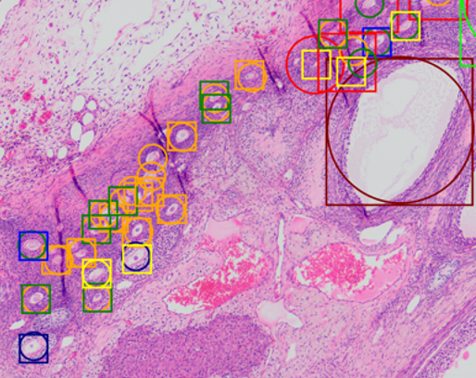

* 1. ***Disagreements_0*** shows only annotations from annotator ‘1’ that are different in classification from annotator ‘2’ annotations.
  2. ***Disagreements_0and1*** shows disagreements between both annotators’ images.
     1. It delineates annotations made by one team member but not by another. This ensures that no follicles are overlooked when determining a consensus identification for the follicle.
  3. ***Disagreements_1*** shows only annotations from annotator ‘2’ that are different in classification from annotator ‘1’ annotations.
  4. ***Disagreements_typ*e** shows where ‘annotator 1’ and ‘annotator 2’ agree in location but disagree on follicle types. 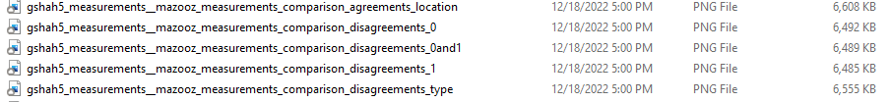

# Annotations Consensus

The output files generated by the “ComparingTwoAnnotators” Jupyter Notebook should be utilized by both the annotators to reach a final consensus on follicle identification and counts for the image.

1. *Annotator 1*  should open the QuPath project file in the consensus count folder.
   1. *Annotator 1* is the person whose file path is added as **fname1 (refer to the “Running the Jupyter Notebook” illustrations above).**
2. *Annotator 2* should navigate to the consensus folder while waiting for the QuPath Project to load on *Annotator 1*’s screen.
3. We recommend navigating to this PNG file first:

*“<annotator1>_measurements_<annotator2>_measurements_comparison_disagreements_type.png”*

* 1. Overlapping shapesindicate that the two annotators did not agree on a follicle’s classification initially. The follicle classification should be discussed by the two team members. Annotator 1 should make the appropriate changes in QuPath after discussion.
  2. Annotations made by one user and not by the other should be reviewed to ensure an accurate total count of follicles. Such discrepancies can be accessed in the file: *“<annototator1>_measurements_<annotator2>_measurements_comparison_disagreements_0and1.png”)*

1. Examples of difficult follicles clarified by Dr. Zelinski from other annotators can be accessed in the MOTHER shared Dropbox folder:
   1. Open the Dropbox App from the desktop bar and click on ‘ASU_OvaryHistology’ $→$‘Macaque_Training Materials’. A] list of training materials should appear.
2. After completing the consensus count, export the annotation table and name it as ***AnimalID_XX_SlidenumberSectionnumber.ome.annotationsTable.txt***

***Example: 14736_UN_050a.ome.annotationsTable.txt***

# Troubleshooting

During the consensus process, annotators may encounter errors while running the Jupyter Notebook or generating output files, which can be resolved using these guidelines. *Before proceeding, double-check that both annotators used the same version of QuPath to complete their annotations and export annotation measurement files.* See **Table 2** for a compiled list of all possible error types along with recommended steps for resolution.

**Table 2:** Generated Error codes by Jupyter Notebook after an unsuccessful code run.

|  |  |  |
| --- | --- | --- |
| **Error Type** | **Meaning** | **Action** |
| Errno 2 | The file directory does not exist | Double-check syntax, punctuation, and backlash placements |
| SyntaxError | Compromised file paths | Double-check syntax. Ensure parentheses, backslashes, and quote(s) are properly closed |
| ValueError | Incorrect path terminology prevents recognition of files | Double-check the written code for inconsistencies |
| KeyError | Inconsequential error | Re-run the code or restart the kernel |
| Alignment Error | The image file of tissue is scaled differently than the Jupyter Notebook | Open “qpproj” as a text file, look for the scaling ratio, and adjust the new ratio with the findings |
| Connection Error | Connection to the kernel server was unsuccessful | Navigate to the re-establishing connection option from the toolbar |

1. **FileNotFoundError: [Errno 2] No such file or directory:** *This error message means that the Jupyter Notebook is not able to locate the file that the user is requesting either because the file does not exist, or the path that was entered contains inconsistencies.*
   1. Ensure that the path in your notebook is **identical** to the path displayed by Dropbox or a File Explorer application, including capitalization, spacing, numbers, and the use of special characters such as underscores or parentheses.
   2. Double-check that the beginning and end of your path contains the same characters, such as a backslash, colon, or quotation mark, according to the example provided above each Input box.
   3. By default, Windows limits the character count for the output filenames and their corresponding paths to 255 characters. Exceeding the limit can result in such an error. To fix this, edit the path to include files in a higher-level directory instead, so the path is shorter. You can then move back the resulting files into the main consensus folder.

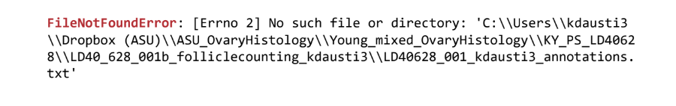

1. **SyntaxError Invalid syntax:***This error message indicates that the Jupyter Notebook has identified a syntactic issue with the path entry, which can usually be fixed easily with a careful review of the complete path.*
   1. Ensure that indentation, brackets, parentheses, slashes, underscores, periods, semicolons, and capitalization are all accounted for in the file paths.
   2. Carefully trace the **complete** path to the desired file and compare between annotator file names to make sure that inconsistencies have been considered.
   3. Utilize the error message provided by Jupyter to locate the issue, by referencing the line number and caret (^) to locate which line or segment of code is compromised.
   4. Refer to example file paths above each Input box in the notebook.
2. **ValueError:** *This error message indicates that the directions provided in the path contained incorrect terminology that is not recognized by the notebook code.*
   1. Check that integers, names, and abbreviations are written out in the same format as in the file name itself and in the auto-generated Dropbox path.
   2. If changes are not solving the issue, delete the path entry and carefully replicate it, ensuring to run only that Input box to ensure the error is resolved.
3. **KeyError: ‘filename’:** *Please reference the screenshot provided below for personal comparison.* 
   1. If this error is encountered at any point, disregard it. This error is inconsequential and will be resolved as soon as the notebook is run to completion.
   2. If the error becomes an issue with consensus file generation, attempt to reset the entire kernel, ensuring that all paths are saved or backed up.

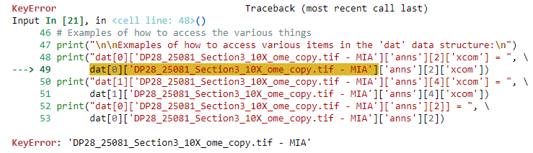

1. **Error: The coordinates in the annotations are not aligning with coordinates in the image:** This error signifies that the ome.tif image file used for the consensus count may have a different scale (μm/pixel) than what is coded for in the master Jupyter notebook.
   1. The scale is defined in the QuPath project file (e.g., “project.qpproj”). You can open the “qpproj” file with a text editor such as Notepad. Look for the following input:   
       "pixelCalibration": {  
       "pixelWidth": {  
       "value": 0.17250000000000001,  
       "unit": "µm"}
      1. To resolve the issue, comment out the line starting with “ sc = 1/0.172500” in the Jupyter Notebook by adding a “#” sign in front of the line
      2. Start a new line beneath these instructions with the correct scaling ratio.
      3. Note: The latest Jupyter Notebook version accommodates this error and therefore should not be encountered.

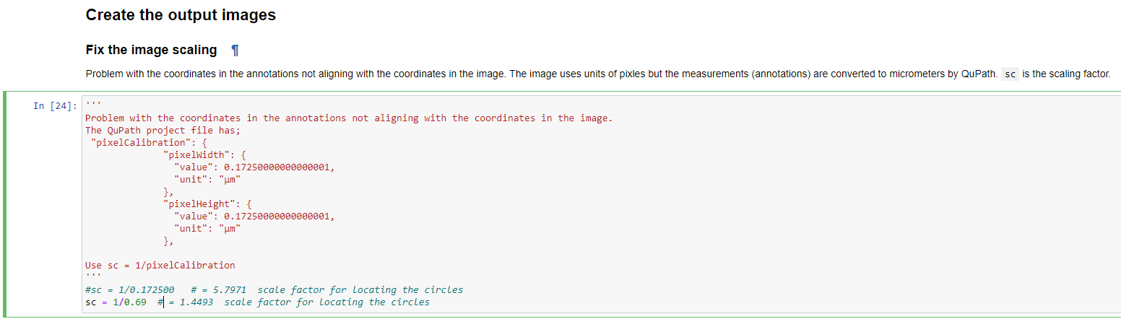

1. **Connection Failed/Autosave Failed**:
   1. To re-establish the connection of your Jupyter Notebook, click on the “File” tab, locate the “Trust Notebook” option from the drop-down menu, then click “Trust Notebook”. This should re-establish the connection.
   2. Be sure to manually save your Jupyter Notebook before making any changes.
   3. If the “Trust Notebook” option is grayed out, exit the page, then reload the Jupyter Notebook and follow the steps above.
2. **Jupyter Notebook won’t run with updated input paths**:
   1. If you made changes to one of your paths after fixing any of the errors seen above, first save your Jupyter Notebook.
   2. Click on the “Kernel” tab in the menu bar.
   3. Within the drop-down menu select “Restart Kernel”, re-save the notebook, then click “Run” to apply the changes.
3. **Issue with locating pixel resolution using original annotation file**:
   1. To view the pixel height in QuPath, open your desired project file, click on the “Image” tab, and locate the descriptor “pixel width and pixel height” midway down the list.
   2. Click on this option and pixel resolution dimensions will be provided to you.
4. **Blurriness issues when viewing consensus disagreement/agreement files:**
   1. Make sure that each generated consensus file is made available offline, and use a regular image viewer such as Windows Photo Viewer or Adobe Bridge to open the file.
   2. The consensus image is named according to the first annotator’s image, so the original png file does not need to be viewed simultaneously.
5. **Disagreement icons offset/scaled incorrectly from consensus output PNG files:** 
   1. Check the following in the final annotation tables for a project:
      1. The measurements are in microns (µm) and not in pixels (px)
      2. If the measurements are in pixels, go to the image tab and change the pixel height and pixel width to 0.6900 microns. You can do so by double-clicking the “*unknown”*  and then typing 0.6900 in the pop-up.

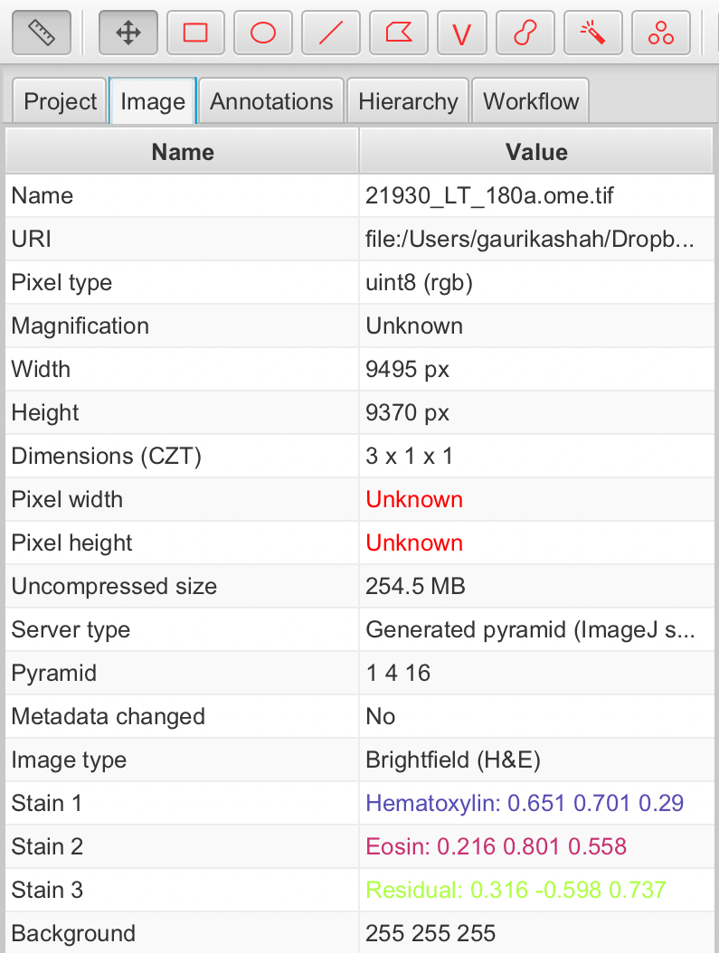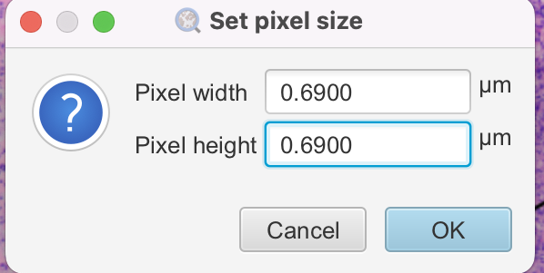

1. **Error loading notebook**:
   1. Check whether the file is properly synced. If not, try syncing or downloading the file again.
   2. After confirming that the file is synced or downloaded, try opening the Jupyter Notebook again.

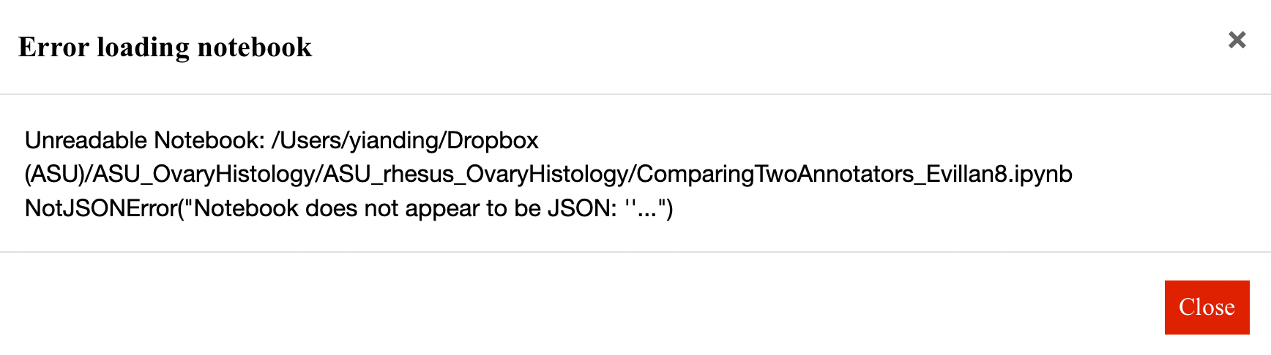

1. **There should be no “Object Id” and “thumbnail” column in your annotations table**.
   1. If there is an object id or a thumbnail column, before saving your annotations table, click on the options button on the bottom right corner and un-select the object id and thumbnail options.

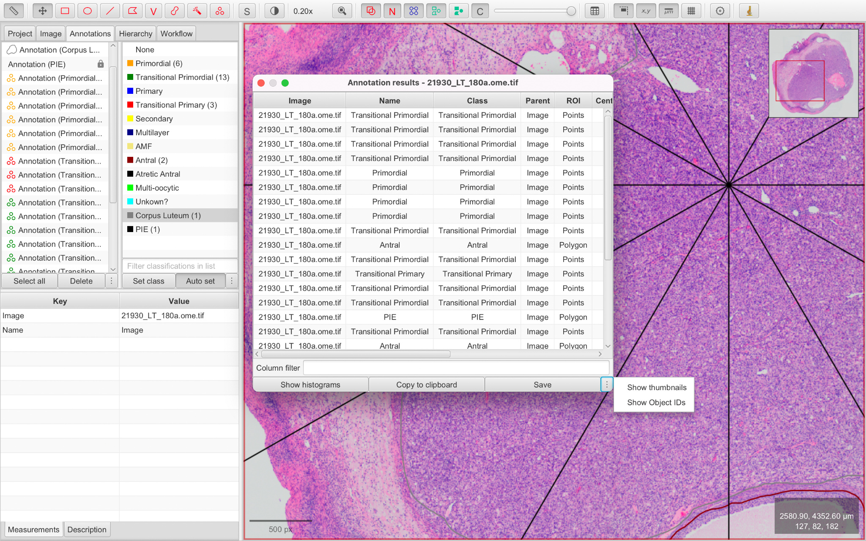

If the steps listed above have not resolved the discrepancy, a PDF copy of the full code should be generated and reported to Dr. Watanabe or Dr. Sluka for further evaluation.

# References

Bankhead, P., Loughrey, M. B., Fernández, J. A., Dombrowski, Y., McArt, D. G., Dunne, P. D., . . . Hamilton, P. W. (2017). QuPath: Open source software for digital pathology image analysis. *Scientific Reports* **7**, 16878, doi:10.1038/s41598-017-17204-5.

Sluka, J., Watanabe, K. & Ding, Y. MOTHER Ovarian Follicle Annotation using QuPath. (2023). <<https://hdl.handle.net/2022/29016>>.

Sluka, J., Watanabe, K., Ding, Y., Zelinski, M. & Dietrich, S. MOTHER Step-by-step supplementary files. (2023). <<https://hdl.handle.net/2022/29015>>.

# Acknowledgments

The “CIBR Multispecies Ovary Tissue Histology Electronic Repository (MOTHER)” is sponsored by the National Science Foundation (NSF DBI-2054061). Any opinions, findings, and conclusions or recommendations expressed in this material are those of the author(s) and do not necessarily reflect the views of the National Science Foundation.